**Sacred Heart Parish Yea – 25th August 2024**

**21st Sunday of Ordinary Time**

**SAINTS FOR THIS WEEK: ST JOACHIM & ST ANNE**

**Recently Deceased**: We keep in our prayers all recently deceased, and those who’s anniversaries occur around this time, that they dwell for ever in God’s loving embrace. Lord Hear Us.

**Anniversaries**: Pemley McCarthy, Gerard Mackrell, Margaret (Mrs) Coonan, Carol Skilling, Fr John Hardy and May McShanag

|  |  |  |  |  |
| --- | --- | --- | --- | --- |
| **Collections last Sunday** | | |  |  |
| Presbytery Account | | $275.00 | Direct Credit | $50.00 |
| Church Account  Special Contribution | | $303.00  $0.00 | Direct Credit | $275.00 |
| **Church Deposits by Direct Credit** | | | |  |
| **Presbytery Account –** for the welfare of bishops and priests | | | | |
| **Sacred Heart Presbytery Account** | | | |  |
| BSB | 633 000 | | Account number | 150 264 992 |
| **Church Account –** for our parish, its mission, welfare and maintenance: | | | | |
| **Sacred Heart Church Account –** for our Priests | | | |  |
| BSB | 633 000 | | Account number | 150 264 778 |

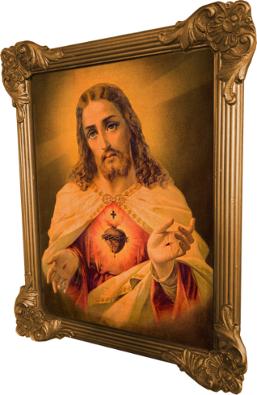**Prayers for those who are sick:** Kate Pittle, Barbara O’Donnell, Rod McKenzie, Michael Tomlinson, Tony Dwyer, Julie Mahony, Len Regan, David Heath and Monika Matteo.

**SAINTS FOR THE WEEK**

**SAINT MONICA – AUGUST 27TH***(c. 332*– 387) was an early North African [Christian](https://en.wikipedia.org/wiki/Christianity) [saint](https://en.wikipedia.org/wiki/Saint) and the mother of [Augustine of Hippo](https://en.wikipedia.org/wiki/Augustine_of_Hippo). She is remembered and honored in the Catholic and Orthodox Churches, albeit on different feast days, for her outstanding [Christian virtues](https://en.wikipedia.org/wiki/Seven_virtues), particularly the suffering caused by her husband's [adultery](https://en.wikipedia.org/wiki/Adultery), and her prayerful life dedicated to the reformation of her son, who wrote extensively of her pious acts and life with her in his [Confessions](https://en.wikipedia.org/wiki/Confessions_(St._Augustine)). Popular Christian legends recall Monica [weeping](https://en.wikipedia.org/wiki/Lacrimation) every night for her son Augustine.

**SAINT AUGUSTINE OF HIPPO – AUGUST 28TH** 5th century theologian, philosopher, bishop and Doctor of the Church. Heavily influenced the development of Western philosophy and Christianity. He helped formulate the doctrine of original sin and made significant contributions to the development of just war theory; becoming one of the most prolific scholars of the early Church. His writings remain a cornerstone of Catholic theology and philosophy. Born in Algeria, in 354, he was sent to study Latin & pagan beliefs when he was just 11. At 17 he went to Carthage to continue his Classical education, while living a hedonistic life. He entered a relationship with a young woman which would last for 15 years. Later, Augustine found a job in Milan, where he was influenced by Ambrose of Milan, who would also go on to become a saint.  
Ambrose adopted Augustine as a spiritual son and converted Augustine to Christianity in 386 at the age of 31, baptising him along with the son from his previous relationship. Ordained a priest in 391, Augustine quickly became famed for his preaching. In 430, the Vandals invaded Roman Africa, besieging Hippo as Augustine entered his final illness. He died shortly. He was canonized by popular acclaim and was recognised as a Doctor of the Church by Pope Boniface VIII in 1298. Throughout his life, he made large contributions to theology and philosophy,

|  |  |  |  |  |  |
| --- | --- | --- | --- | --- | --- |
| **Roster** | **Readers** | | **Prayers** | **Counter** | **Flowers** |
| 25th August 2024 | M. Oliver. J. Forde | P. O’Connor | | C. Jansen | H. Hauser |
| 1st September 2024 | C. Rattray M. Mahon | J. Hard | | E. McAleer | J. Hard |

**Sacred Heart Parish Yea**

Established 1890

Email: [yea@cam.org.au](mailto:yea@cam.org.au)

Phone: (03) 5899 9128

P.O. Box 61 YEA 3717

Website: www.shyea.catholic.edu.au

**Holy Mass Times**

Yea –Sunday 10:45am, Tuesday 5:00pm and Rosary, Thursday 9:00am

Alexandra – Sunday 8:45am, Wednesday 9:30am, Friday 9:00am

Parish Priest:

**Fr Jose Mathew** 0459 402 547

Secretary:   
**Sacred Heart Primary School**  
Principal: Kathryn Stuart

03 5797 2723

Reconciliation: **Fr Jose Mathew** 0459 402 547

Yea – Tuesday before Mass from 4:30pm and Sunday after Holy Mass approximately at 11:45am

Alexandra – Friday before Holy Mass and before Sunday Holy Mass from 8am